

**Bahirdar Universty**

**Course : Operating System (OS)**

**Assignment-3**

**Submitted by:- Abrham Desalegn**

**ID 1600609**

**Department:IS**

**Submit to : Lec . Alemitu**

**Red Hat Enterprise Linux (RHEL) Server Installation Using Virtual Machine**

## ****Introduction****

This document describes the complete procedure for installing **Red Hat Enterprise Linux (RHEL) Server** on a **virtual machine.** The installation is performed from scratch using virtualization software, covering VM creation, configuration, operating system installation, error handling, and post-installation verification.

**Red Hat Enterprise Linux (RHEL) Server** is a stable, secure, and enterprise-grade Linux OS used to run mission-critical applications and services.

**Key Roles:**

* **Application Hosting:** Run web apps, databases, and business software.
* **File & Data Management:** Secure storage and data sharing.
* **Network Services:** DNS, email, web, and other essential services.
* **Virtualization & Containers:** Support for KVM, Docker, and OpenShift.
* **Security & Compliance:** SEL inux, firewalls, and regulatory compliance.

## ****Prerequisites****

**Official RHEL download page (free for developers / trial):**  
[Download Red Hat Enterprise Linux (RHEL) Server from Red Hat Developer](https://developers.redhat.com/products/rhel/download?utm_source=chatgpt.com)

Before starting the installation, ensure the following requirements are met:

* RHEL Server ISO file (RHEL 8.1 version)
* Virtualization software (Oracle VirtualBox / VMware / KVM)
* Minimum system requirements:
  + CPU: 2 cores
  + RAM: 4 GB (8 GB recommended for GUI)
  + Disk space: 40 GB
* Internet connection (optional)
* Red Hat account (for subscription registration)

**Virtual Machine Creation**

### ****Step 1: Launch Virtualization Software****

Open the virtualization software installed on the host system (e.g., Oracle VirtualBox).

### ****Step 2: Create a New Virtual Machine****

1. Click **New**.
2. Enter the VM name (e.g., RHEL-Server).
3. Select:
   * Type: **Linux**
   * Version: **Red Hat (64-bit)**
4. Click **Next**.

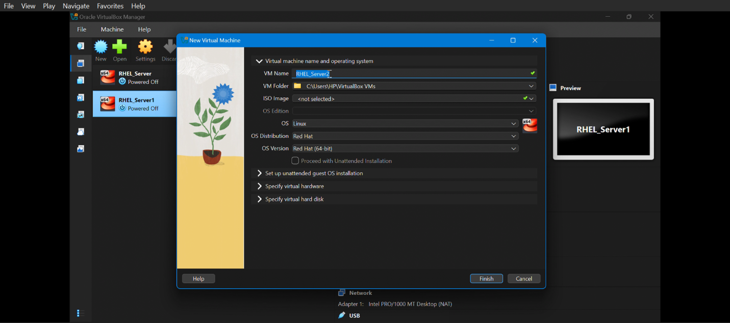

### ****Step 3: Specify Virtual Hardware****

1. Assign Base Memory **4096 RAM**.
2. Assign Number of **2 CPU cores**.
3. Click **Next**.

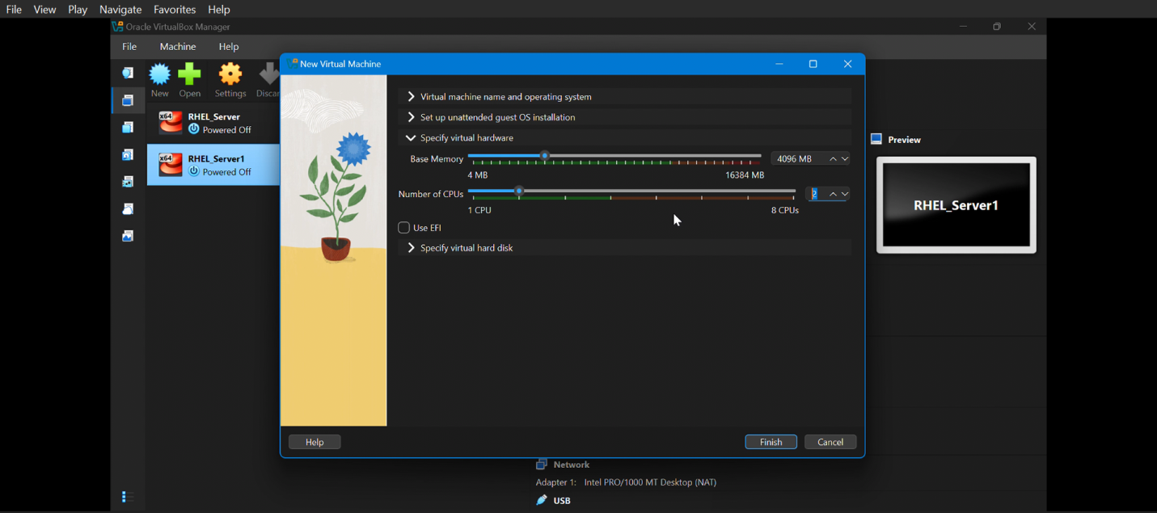

### ****Step 4: Specify Virtual Hard Disk****

1. **Select Create a virtual hard disk now.**
2. **Choose VDI (Virtual Disk Image).**
3. **Select Dynamically allocated.**
4. **Set Disk Size 50GB**
5. Click **Finish**

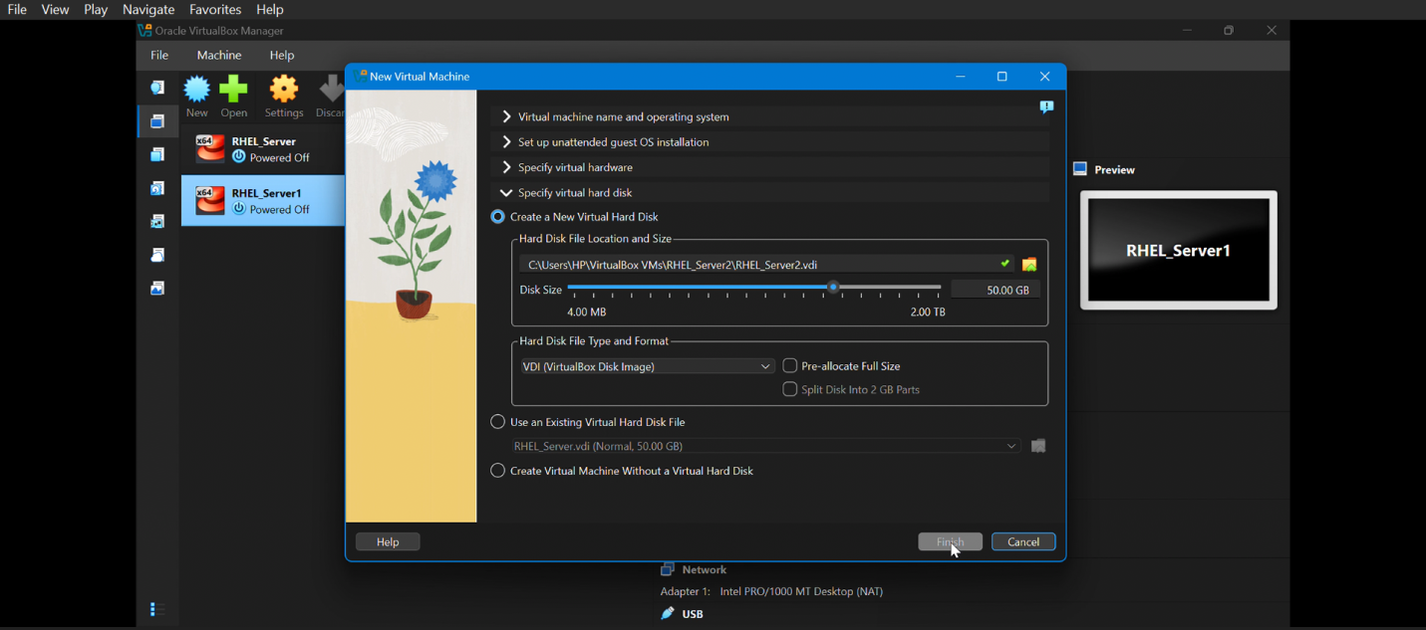

**VM Hardware Configuration**

### ****Step 5: Attach RHEL ISO File****

1. Open **VM Settings**.
2. Go to **Storage**.
3. Under Controller IDE, attach the **RHEL ISO file**.
4. Confirm the ISO is selected as boot media.

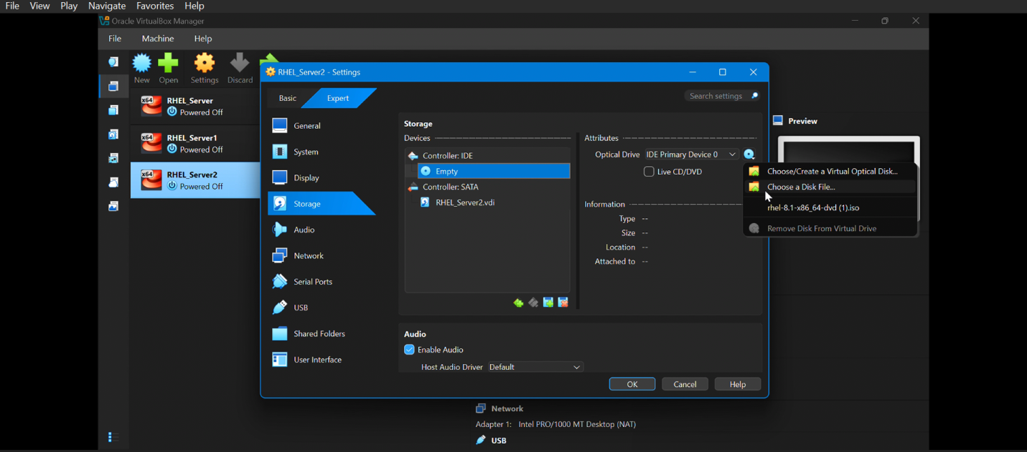

### ****Step 6: Change Pointing Device to USB Tablet****

1. Locate the **Pointing Device** dropdown.
2. Change the selection from: PS/2 Mouse **to** USB Tablet

This enables absolute mouse positioning.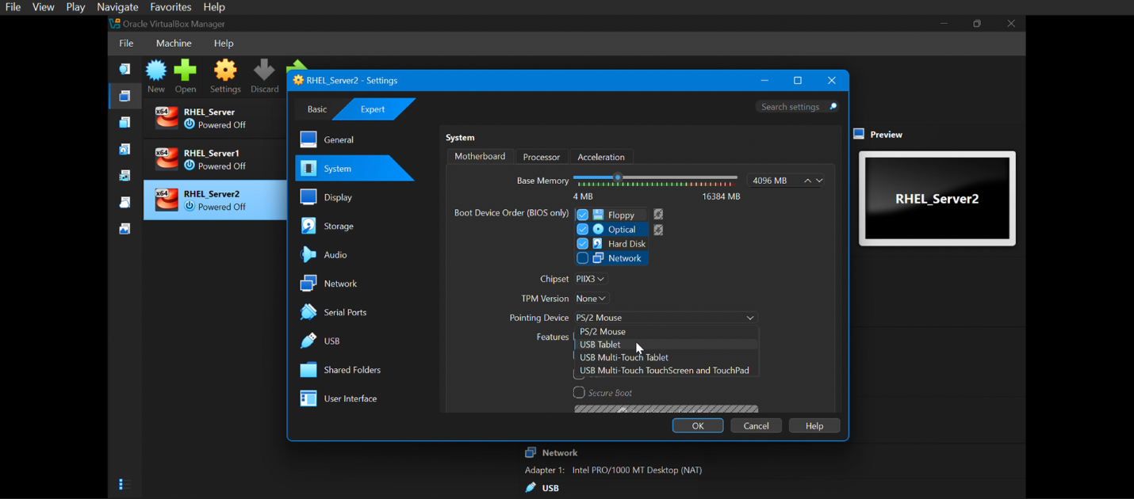

## ****Booting the Virtual Machine****

### ****Step 8: Start the Virtual Machine****

1. Click **Start**.
2. The VM boots from the RHEL ISO.
3. The RHEL boot menu appears.

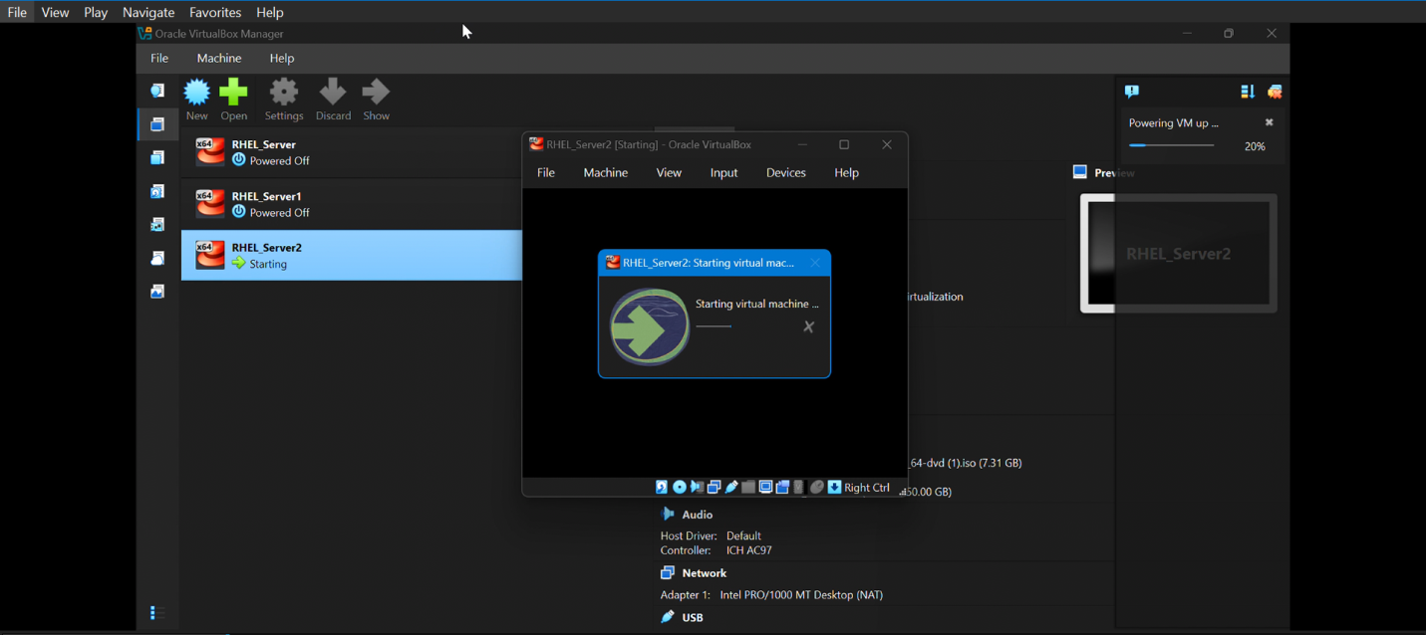

### ****Step 9: Select Installation Option****

**Choose Install Red Hat Enterprise Linux and press Enter.**

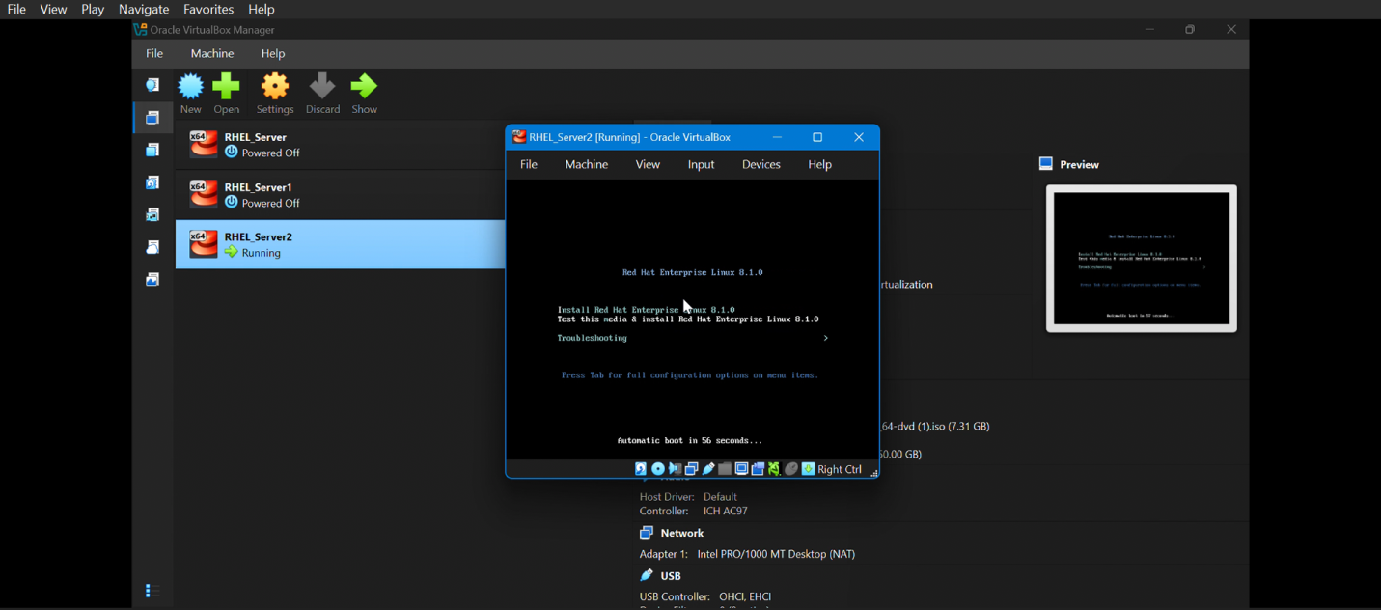

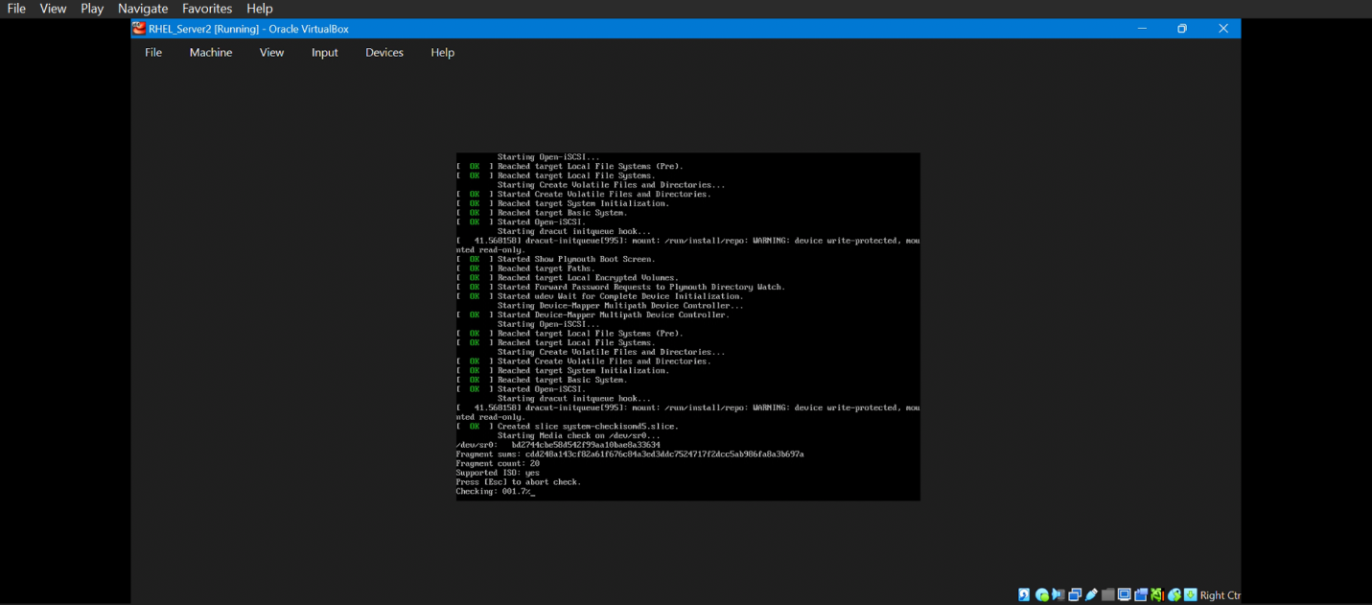

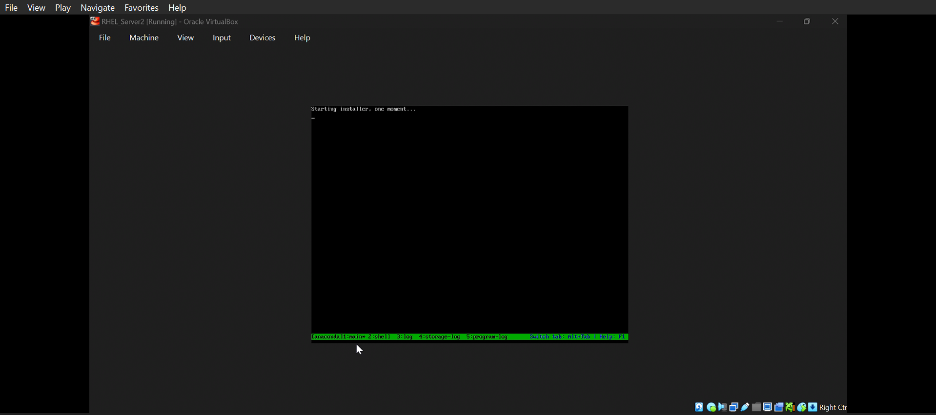

## ****RHEL Installer Configuration****

### ****Step 10: Select Language****

1. Choose the preferred installation language.
2. Click **Continue**.

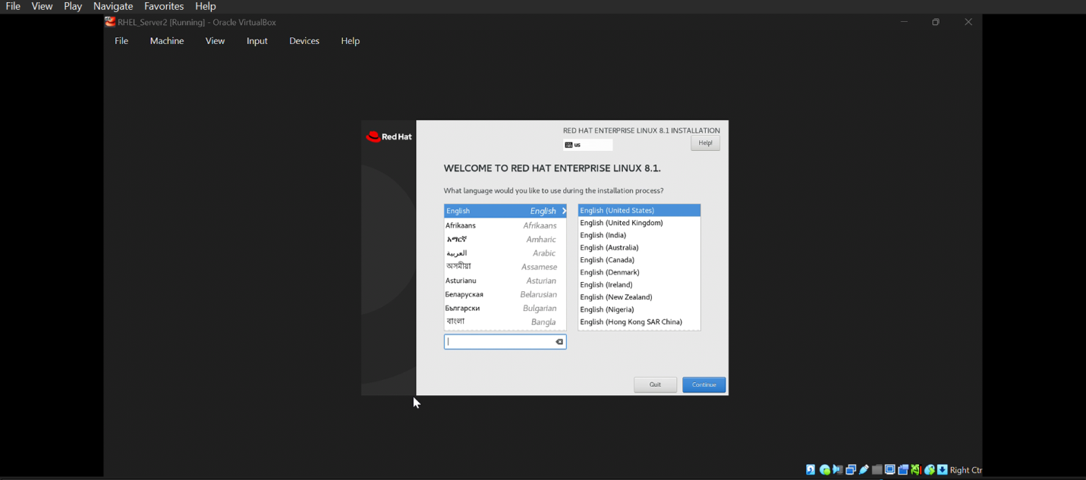

## ****Disk Configuration****

### ****Step 13: Installation Destination****

1. click **Installation Destination**.
2. The installer displays the available storage devices detected by the system.
3. Select the virtual disk created for the RHEL virtual machine.
4. Choose **Automatic partitioning** to allow the installer to create the required partitions automatically.
5. Leave all other storage and partitioning options **set to their default values.**
6. Review the selected disk to ensure it is correct.
7. Click **Done** to confirm the installation destination.

But other things on this page use as default

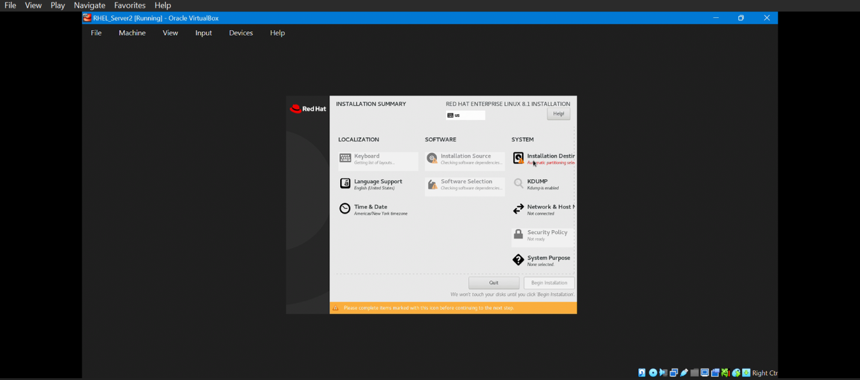

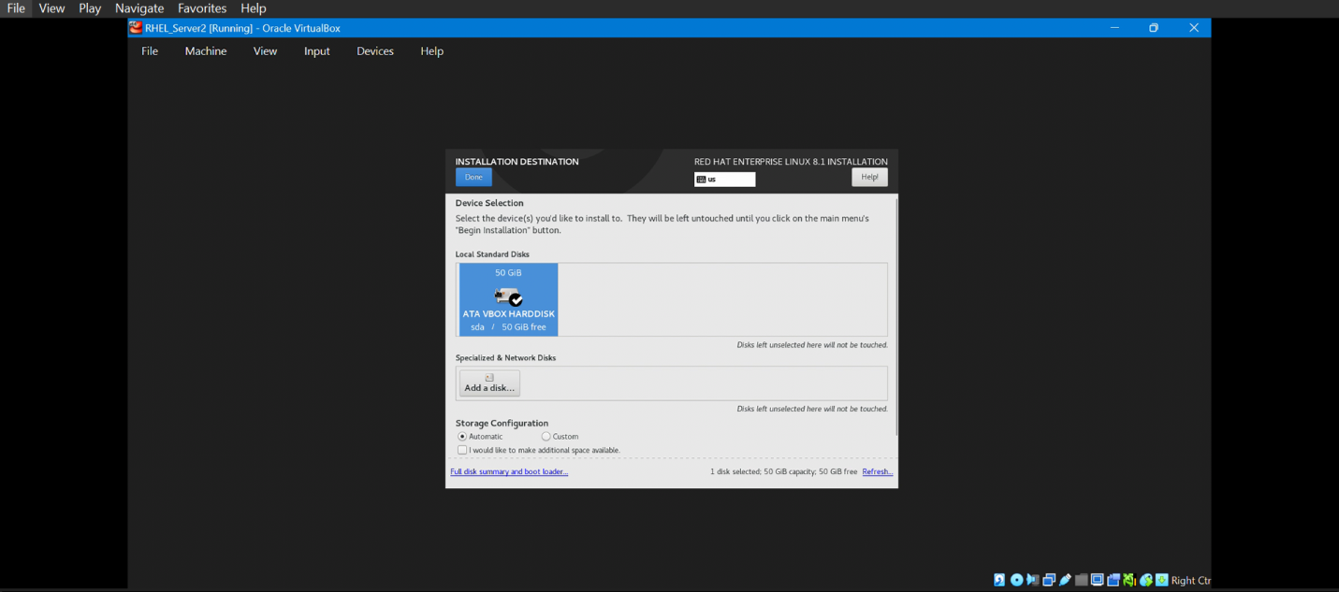

## ****User and Security Configuration****

### ****Step 17: Set Root Password****

1. click **Root Password**.
2. Enter a strong password for the root (administrator) account.
3. Re-enter the password to confirm it.
4. Ensure the password meets the required security complexity.
5. Click **Done** to apply the root password configuration.

Setting a secure root password ensures proper administrative access to the system after installation.

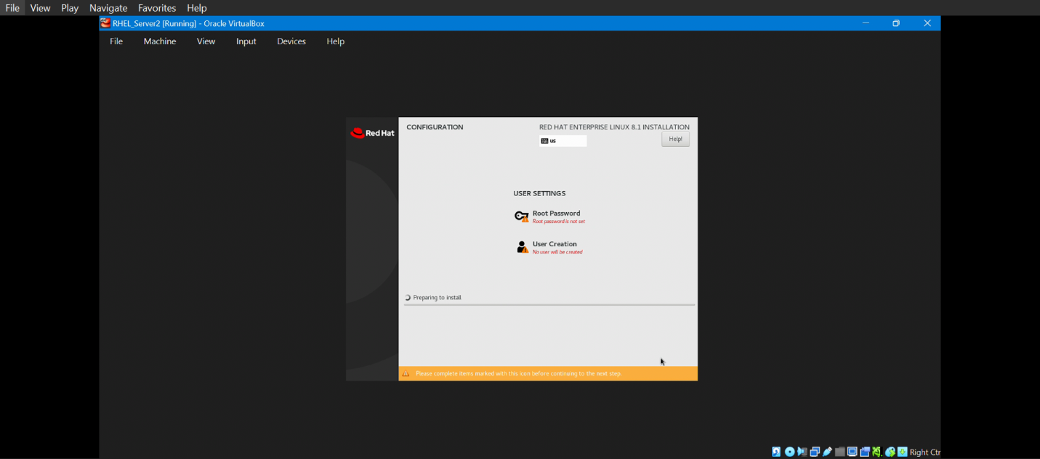

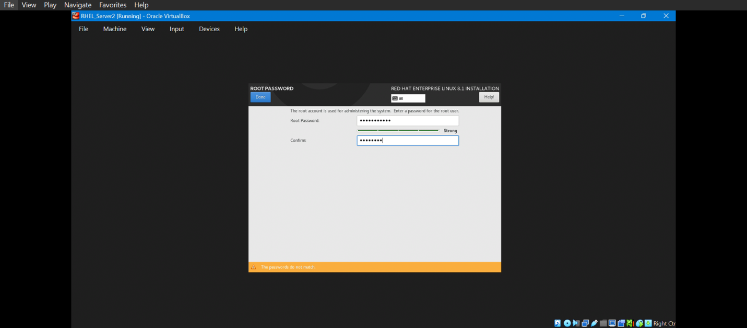

### ****Step 18: Create User Account****

1. click **User Creation**.
2. Enter the required user details, including:
   * Full name
   * Username
   * Password
3. Confirm the password by re-entering it.
4. (Optional) Enable **Make this user administrator** to grant sudo (administrative) privileges.
5. Review the entered information for accuracy.
6. Click **Done** to save the user account configuration.

Creating a user account allows secure, non-root access to the system and is recommended for day-to-day administration tasks.

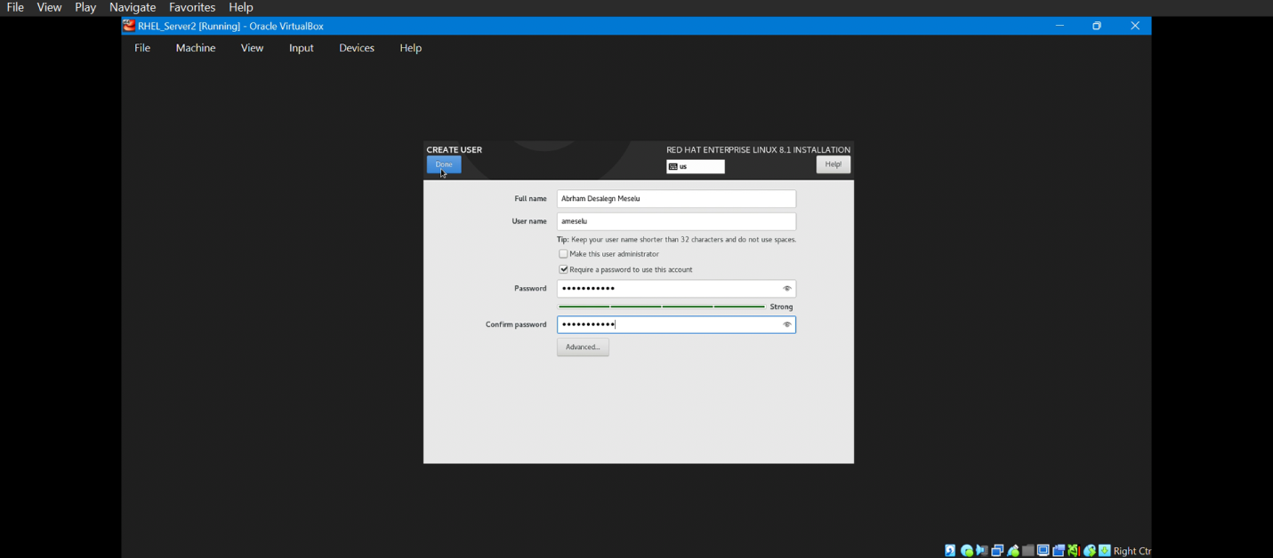

**Begin Installation**

### ****Step 19: Begin Installation****

1. After completing all required configuration options in the installation summary screen, review the selected settings to ensure accuracy.
2. Click **Begin Installation** to start the RHEL Server installation process.
3. The installer copies system files, installs selected software packages, and applies system configurations automatically.
4. Monitor the installation progress displayed on the screen.
5. Wait until the installation process completes successfully before proceeding.

This step initiates the actual installation of Red Hat Enterprise Linux Server on the virtual machine.

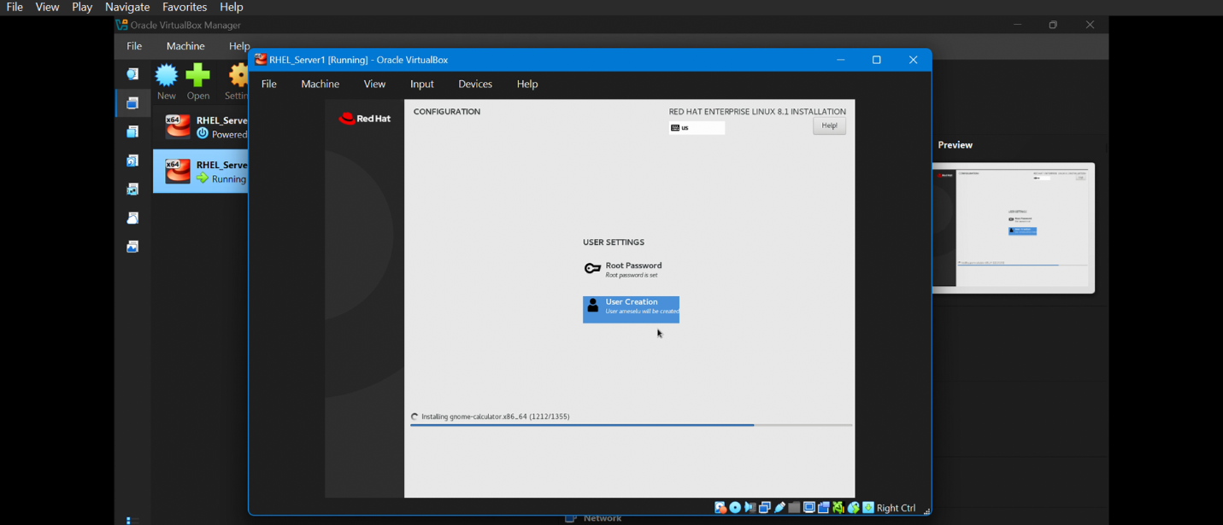

**Post-Installation Tasks**

### ****Step 20: Reboot the System****

1. Once the installation process is completed, the installer displays the **Installation Complete** message.
2. Click **Reboot System** to restart the virtual machine.
3. During reboot, remove the RHEL ISO file from the virtual optical drive to prevent the system from booting into the installer again.
4. Allow the system to boot from the newly installed virtual hard disk.
5. Wait until the RHEL login screen appears.

The reboot process finalizes the installation and transitions the system to normal operating mode.

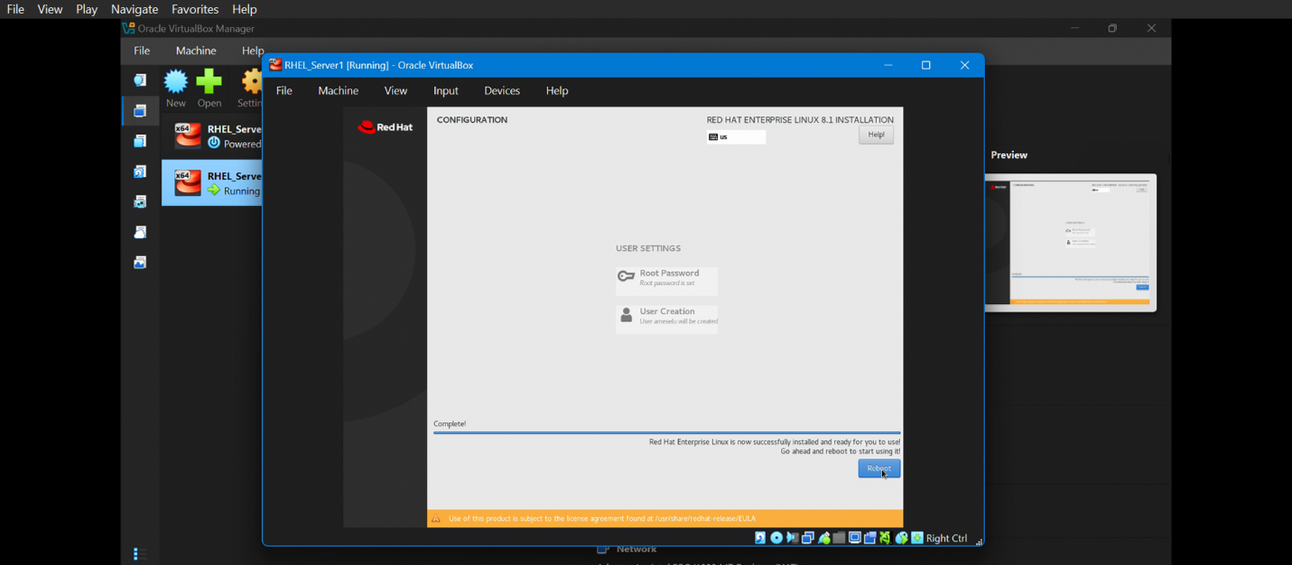

### ****Step 21: First Login****

1. After the system reboots, the RHEL login screen is displayed.
2. Select the user account created during installation or choose the **root** user.
3. Enter the appropriate username and password.
4. Click **Sign In** or press **Enter.**
5. Verify that the system loads successfully into: the **command-line interface (CLI)** for minimal installations, or the **graphical desktop environment (GUI)** for GUI-based installations.

Successful login confirms that the RHEL Server installation has completed correctly and the system is ready for further configuration.

